Real-time Operating System - 48450
Assignment 2 Report

Student Name:
Student ID:

Table of Contents
I. Introduction 2
II. Implementation 2
1. Method 2
2. Flow chart and/or Gantt Chart 2
III. Experiments 2
IV. Conclusion 3
V. References 3

- Introduction
In this section, an introduction about the assignment is presented and some core technical knowledge that you will use are highlighted.

- Implementation
- Method
In this section, you are required to list the concepts that are used to fulfil the design in your program.
- Flow chart and/or Gantt Chart
You might draft a flow chart and/or a Gantt chart about your program.

- Experiments
For demonstration purpose, you might give some graphs about your program running. An example is shown below.
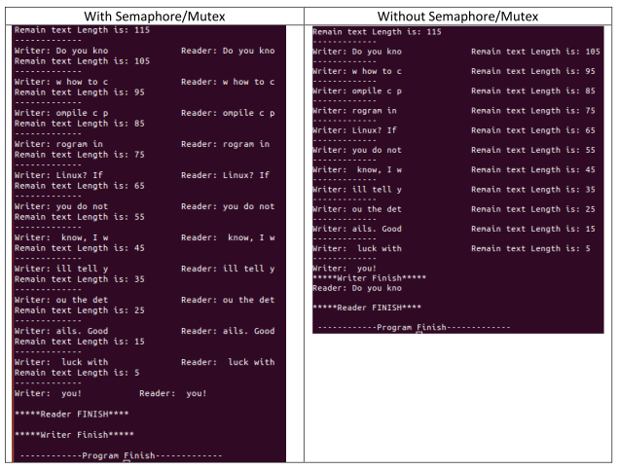
Figure 1. Sample of the figure -- Experimental results with and without semaphore/mutex.

- Conclusion
You might give a summary about your work on the assignment 2. What you have learned and your expectation
- References
If you have references, please referee them correctly.
A. Silberschatz, P. B. Galvin & G. Gagne, 2012, Operating System Concepts, 9 th edn, John Wiley & Sons, New York.

